Simple R Programs

1.Factorial

n <- as.integer(readline("Enter a number: "))

fact <- 1

for (i in 1:n) {
fact <- fact * i
}

cat("Factorial of", n, "=", fact)

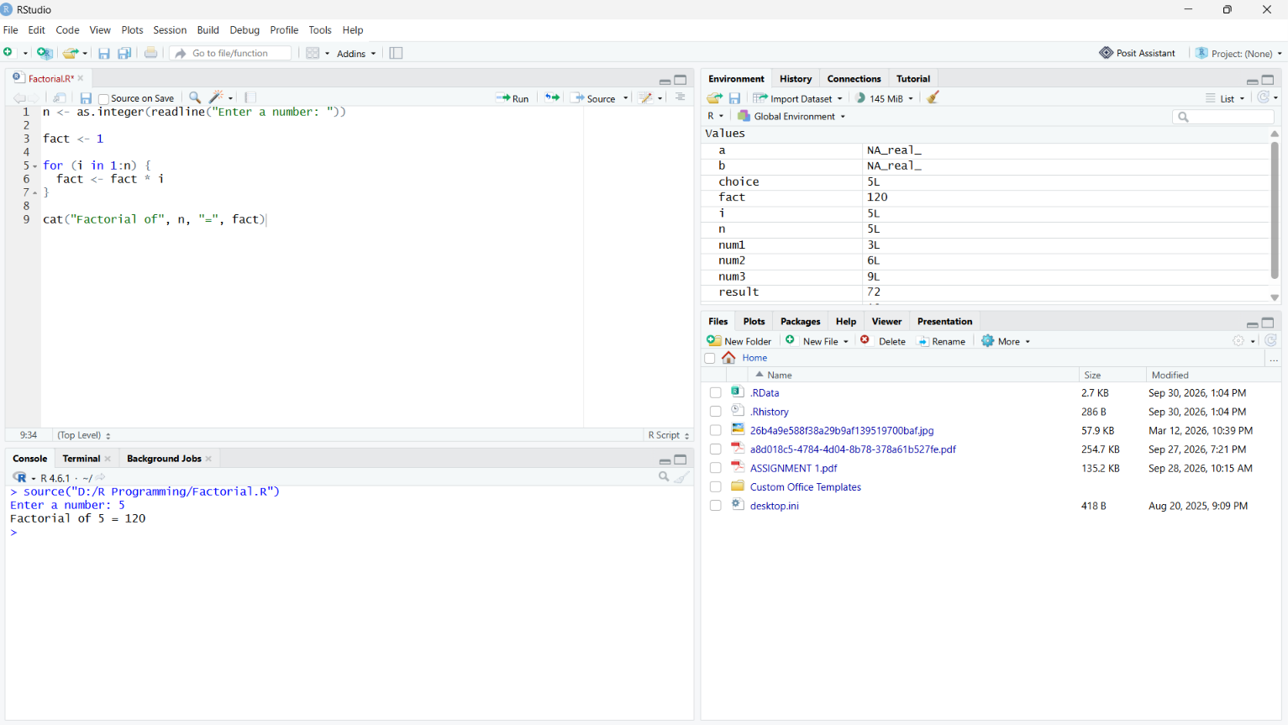

2. Fibonacci
n <- as.integer(readline("Enter number of terms: "))

a <- 0
b <- 1

cat("Fibonacci Series: ")

for (i in 1:n) {
cat(a, " ")

c <- a + b
a <- b
b <- c
}
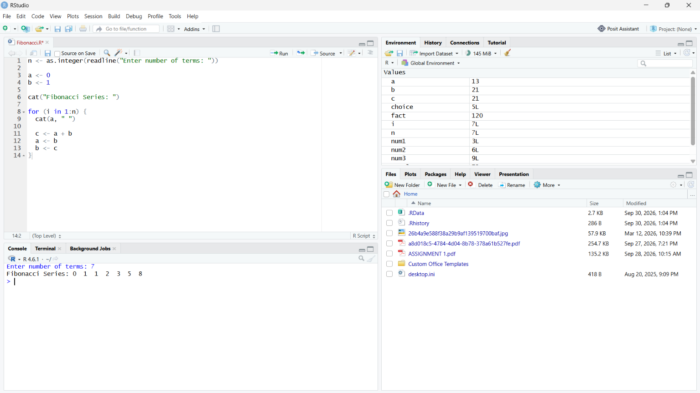

3.Sum of first n natural number

n <- as.integer(readline("Enter n: "))

sum <- 0

for (i in 1:n) {
sum <- sum + i
}

cat("Sum =", sum)

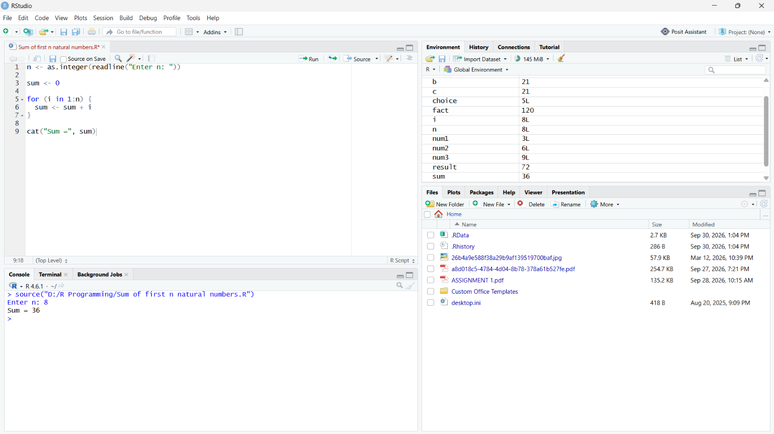

4.Sum of squares of first n natural numbers
n <- as.integer(readline("Enter n: "))

sum <- 0

for (i in 1:n) {
sum <- sum + i^2
}

cat("Sum of squares =", sum)

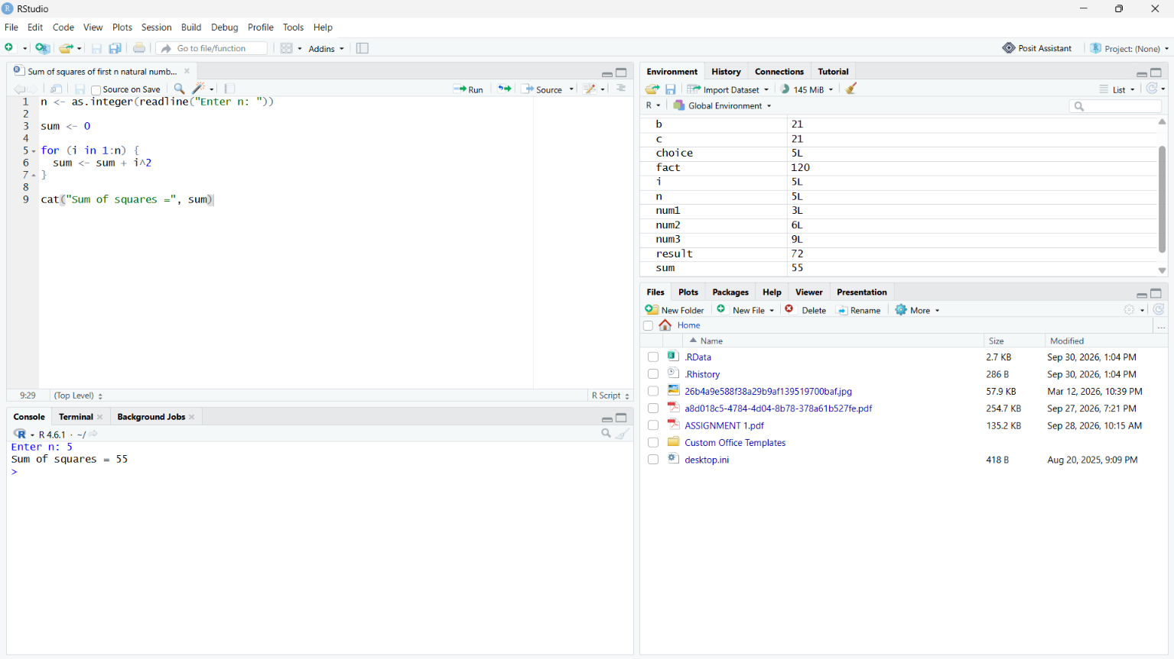

5. Sum of cubes of first n natural numbers

n <- as.integer(readline("Enter n: "))

sum <- 0

for (i in 1:n) {
sum <- sum + i^3
}

cat("Sum of cubes =", sum)

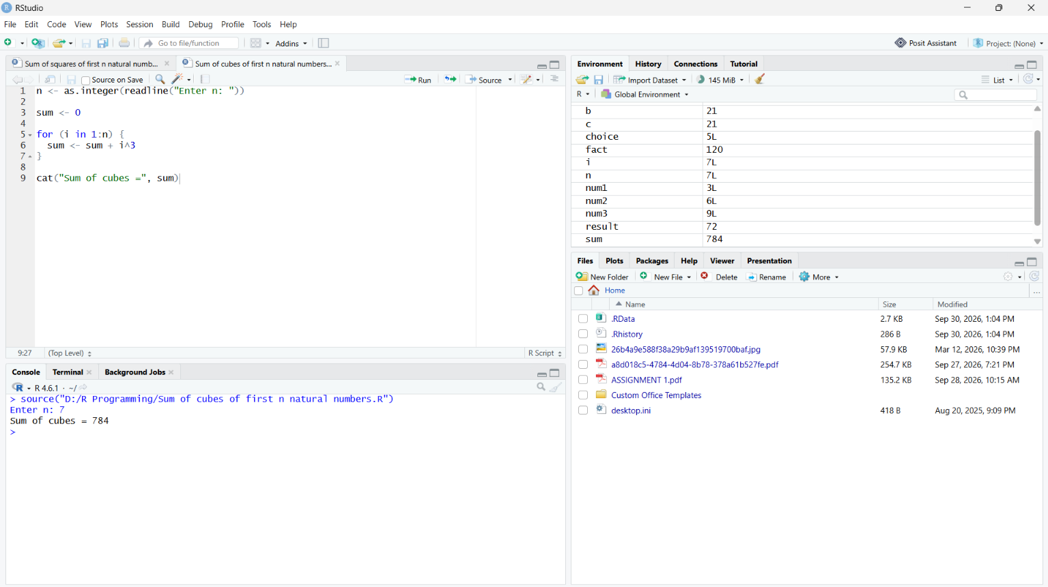

6. Generate series 1 + 2 + 3 + ... + n and calculate its sum
n <- as.integer(readline("Enter n: "))

sum <- 0

cat("Series: ")

for (i in 1:n) {
cat(i)

if (i < n) {
cat(" + ")
}

sum <- sum + i
}

cat("\nSum =", sum)
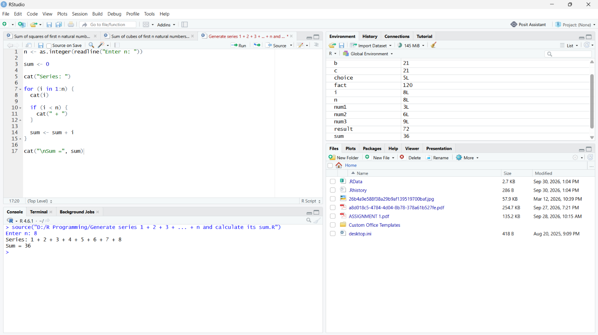
7. Calculate the series 1² + 2² + ... + n²
n <- as.integer(readline("Enter n: "))

sum <- 0

cat("Series: ")

for (i in 1:n) {
cat(i, "^2")

if (i < n) {
cat(" + ")
}

sum <- sum + i^2
}

cat("\nSum =", sum)
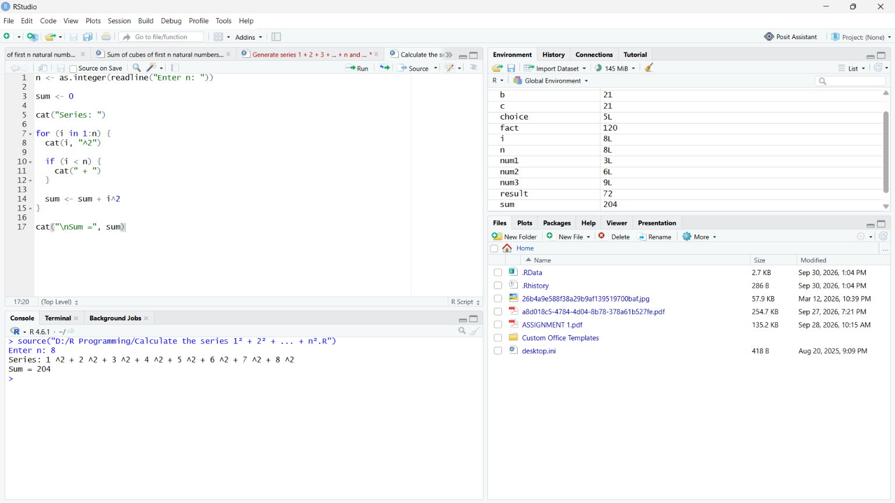
8. Calculate the series 1³ + 2³ + ... + n³
n <- as.integer(readline("Enter a number: "))
if (n < 2) {
cat(n, "is not a prime number")
} else {
flag <- 0

for (i in 2:(n - 1)) {
if (n %% i == 0) {
flag <- 1
break
}
}
if (flag == 0) {
cat(n, "is a prime number")
} else {
cat(n, "is not a prime number")
}
}
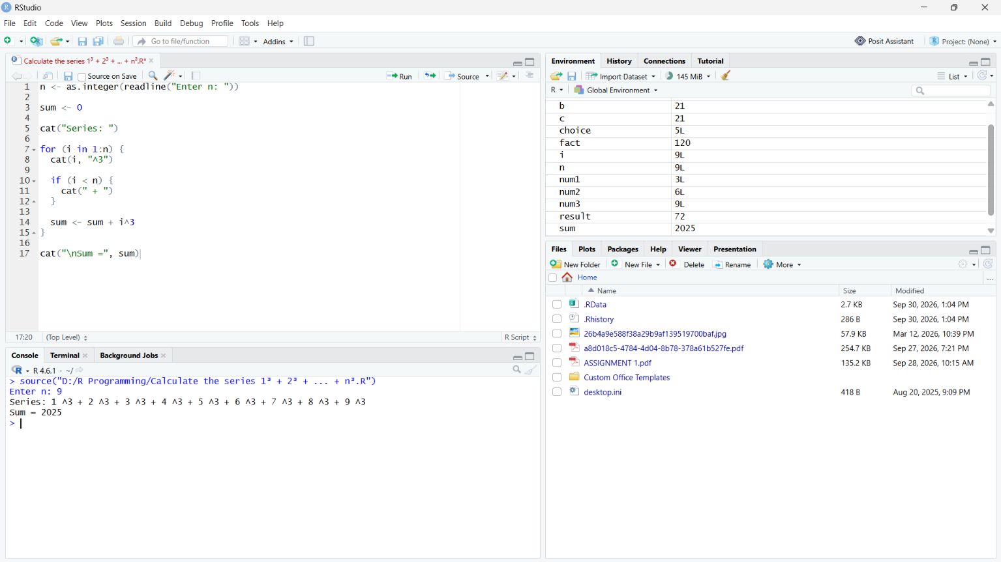
9. Check whether a number is prime or not
n <- as.integer(readline("Enter a number: "))

if (n < 2) {
cat(n, "is not a prime number")
} else {
flag <- 0

for (i in 2:(n - 1)) {
if (n %% i == 0) {
flag <- 1
break
}
}

if (flag == 0) {
cat(n, "is a prime number")
} else {
cat(n, "is not a prime number")
}
}
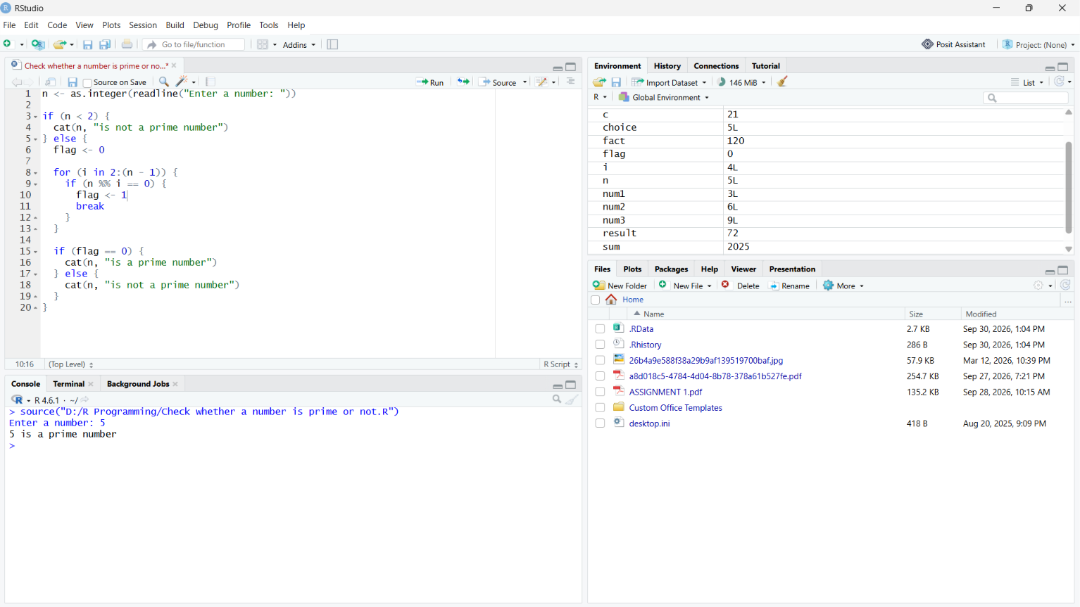
10. Display all prime numbers between 1 and n
n <- as.integer(readline("Enter n: "))

cat("Prime numbers: ")

for (num in 2:n) {

flag <- 0

for (i in 2:(num - 1)) {
if (num %% i == 0) {
flag <- 1
break
}
}

if (flag == 0) {
cat(num, " ")
}
}
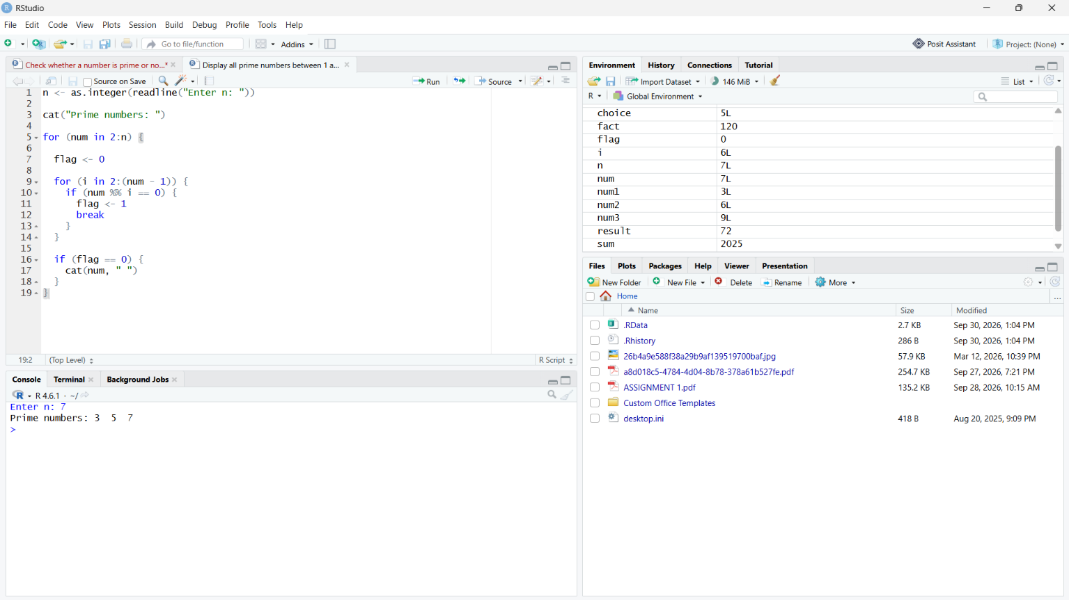
11.Check whether a number is even or odd
n <- as.integer(readline("Enter a number: "))

if (n %% 2 == 0) {
cat(n, "is even")
} else {
cat(n, "is odd")
}

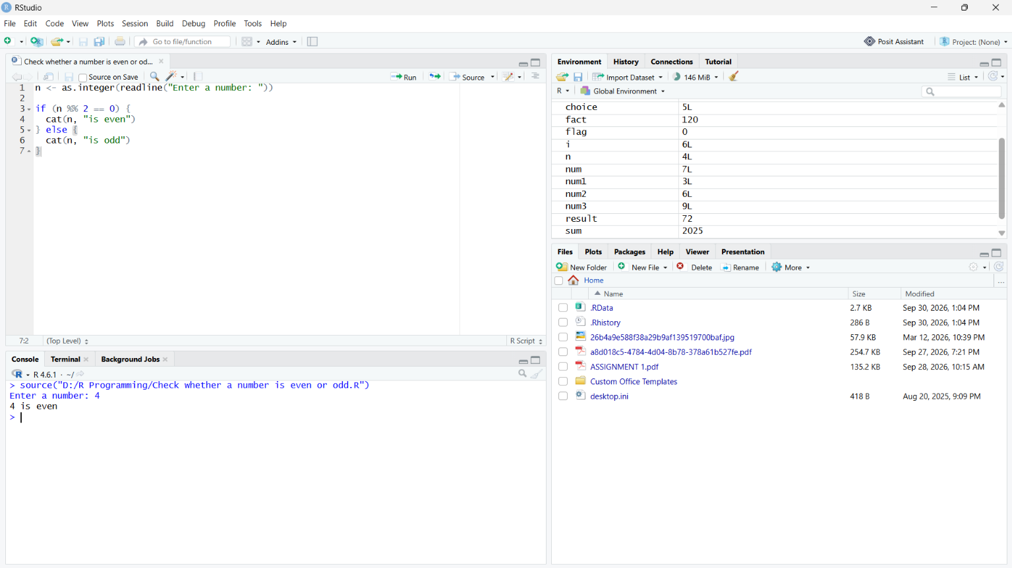

12. Find the largest of three numbers
a <- as.numeric(readline("Enter first number: "))
b <- as.numeric(readline("Enter second number: "))
c <- as.numeric(readline("Enter third number: "))

if (a >= b && a >= c) {
largest <- a
} else if (b >= a && b >= c) {
largest <- b
} else {
largest <- c
}

cat("Largest number =", largest)

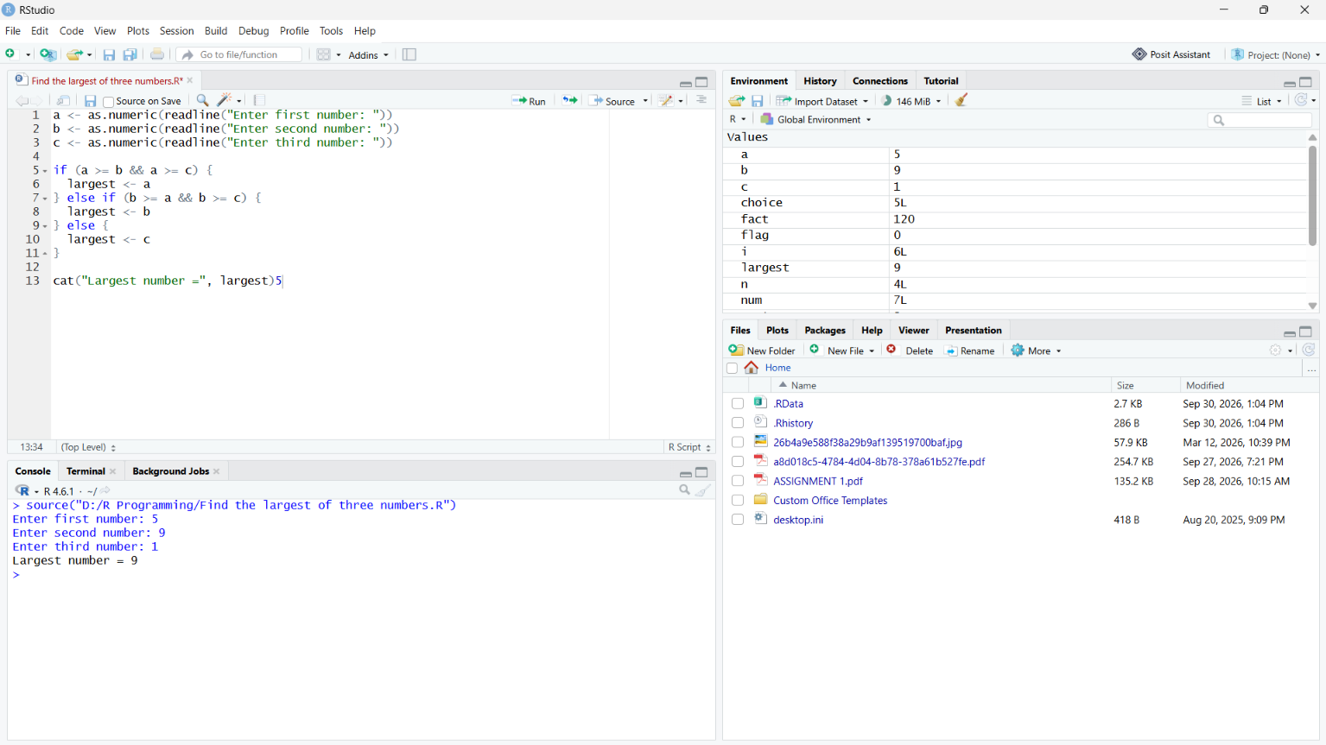

13. Find the smallest of three numbers
a <- as.numeric(readline("Enter first number: "))
b <- as.numeric(readline("Enter second number: "))
c <- as.numeric(readline("Enter third number: "))

if (a <= b && a <= c) {
smallest <- a
} else if (b <= a && b <= c) {
smallest <- b
} else {
smallest <- c
}

cat("Smallest number =", smallest)

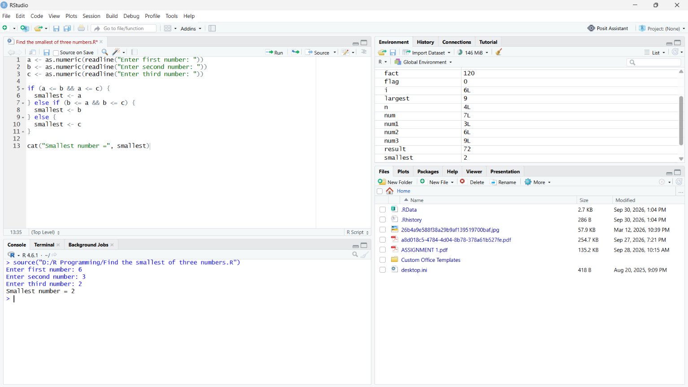

Reverse a given number
n <- as.integer(readline("Enter a number: "))

reverse <- 0

while (n > 0) {
digit <- n %% 10
reverse <- reverse * 10 + digit
n <- n %/% 10
}

cat("Reverse =", reverse)

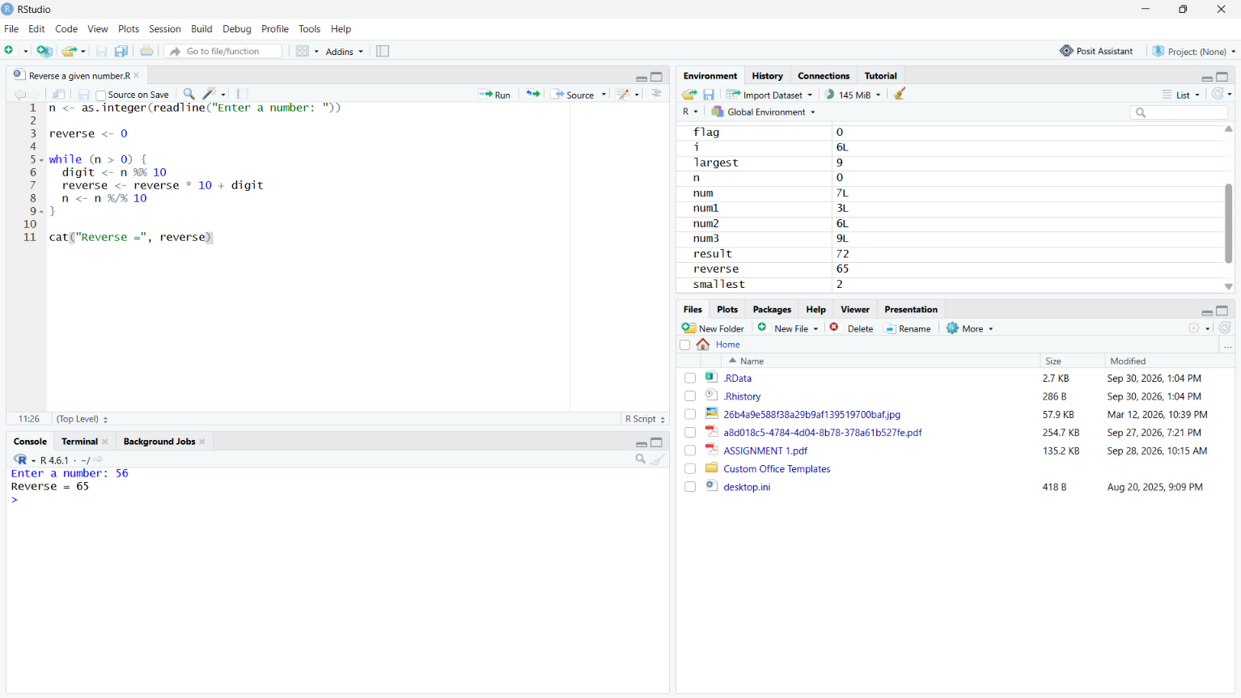

15. Check whether a number is a palindrome
n <- as.integer(readline("Enter a number: "))

original <- n
reverse <- 0

while (n > 0) {
digit <- n %% 10
reverse <- reverse * 10 + digit
n <- n %/% 10
}

if (original == reverse) {
cat(original, "is a palindrome")
} else {
cat(original, "is not a palindrome")
}
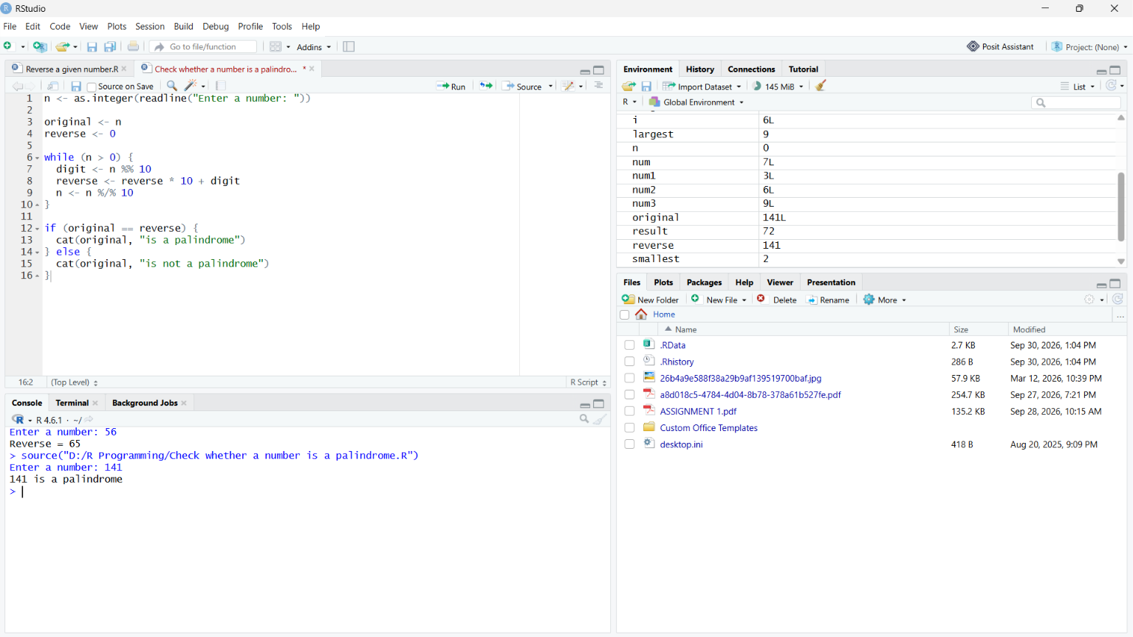

16. Find the sum of digits of a number
n <- as.integer(readline("Enter a number: "))

sum <- 0

while (n > 0) {
digit <- n %% 10
sum <- sum + digit
n <- n %/% 10
}

cat("Sum of digits =", sum)

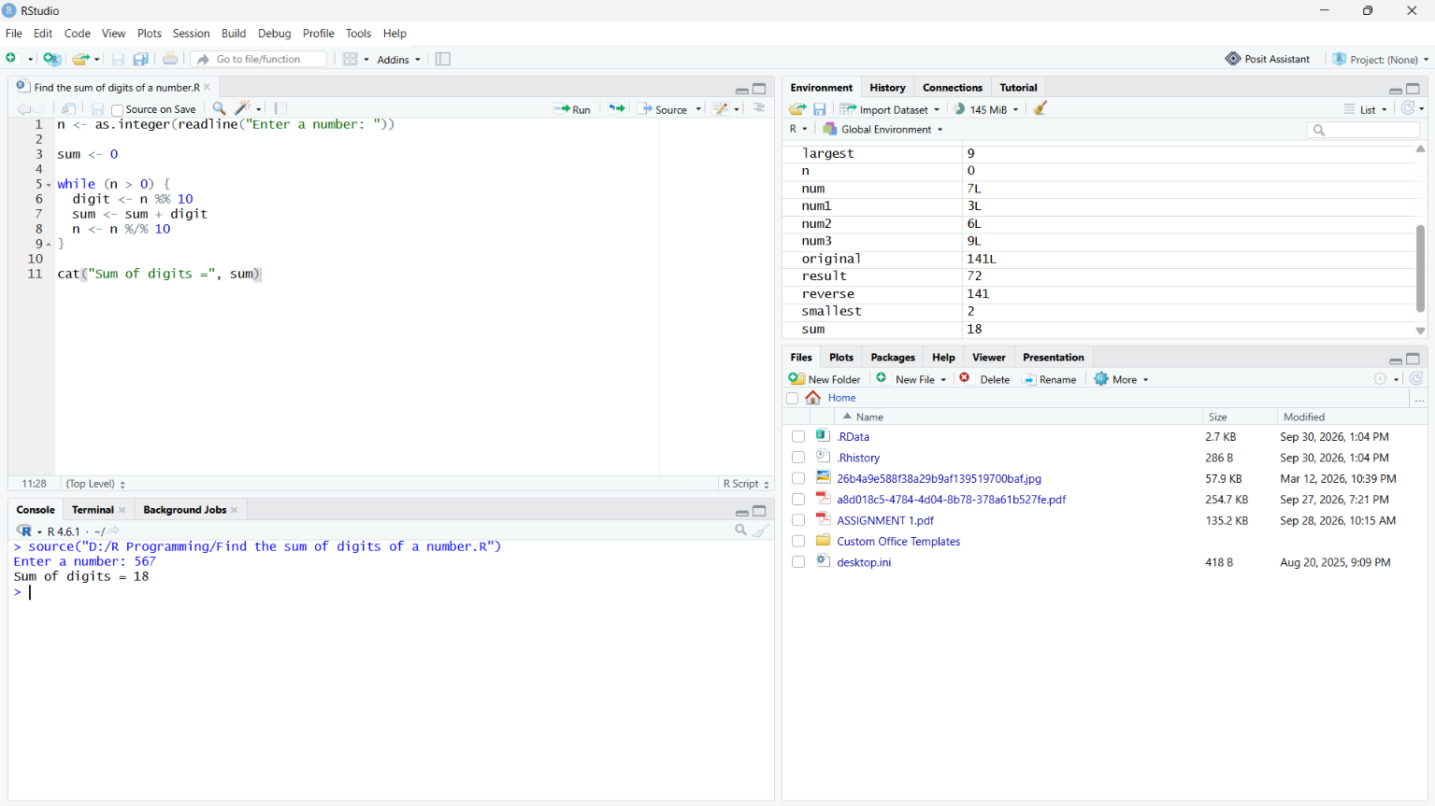

17. Count the number of digits
n <- as.integer(readline("Enter a number: "))

count <- 0

if (n == 0) {
count <- 1
} else {
while (n > 0) {
count <- count + 1
n <- n %/% 10
}
}

cat("Number of digits =", count)
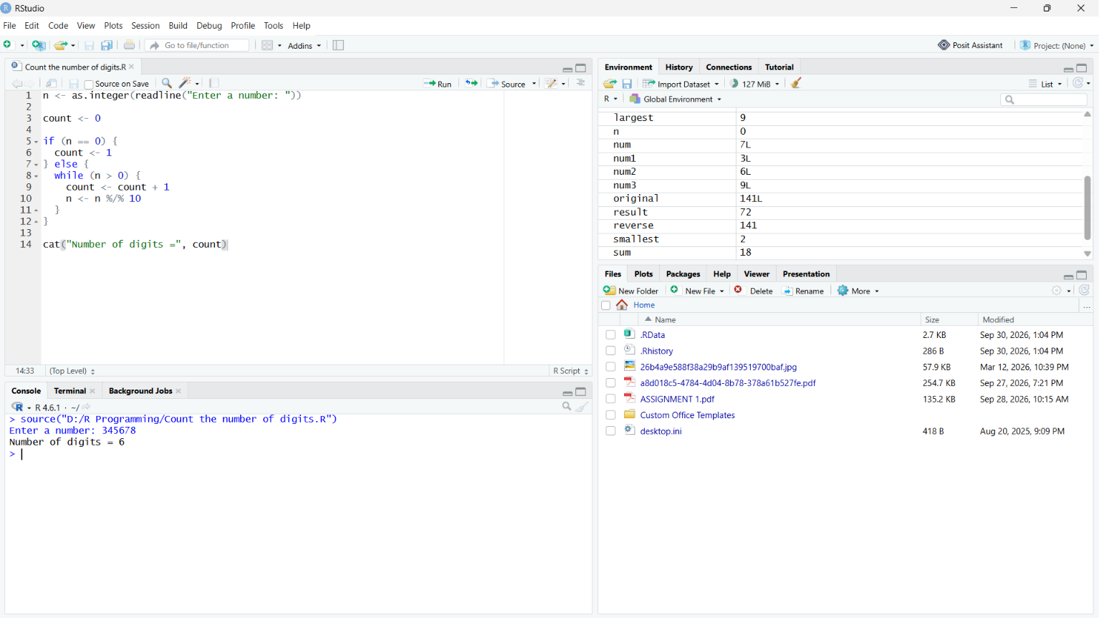

18. Check whether a number is an Armstrong number
n <- as.integer(readline("Enter a number: "))

original <- n
temp <- n
count <- 0

while (temp > 0) {
count <- count + 1
temp <- temp %/% 10
}

sum <- 0
temp <- n

while (temp > 0) {
digit <- temp %% 10
sum <- sum + digit^count
temp <- temp %/% 10
}

if (sum == original) {
cat(original, "is an Armstrong number")
} else {
cat(original, "is not an Armstrong number")
}
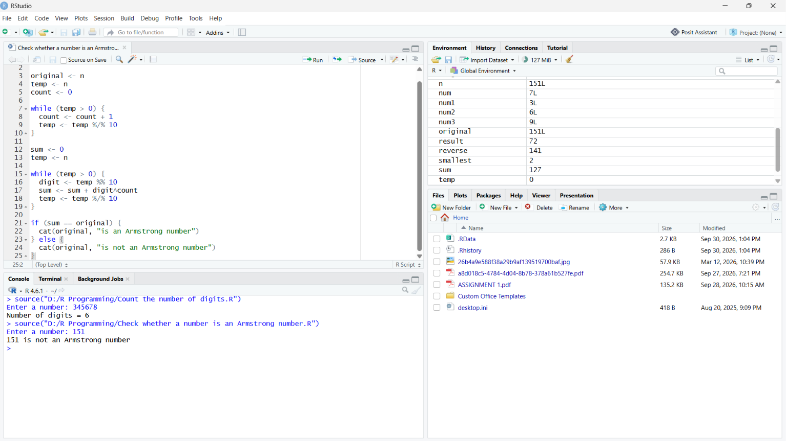

19. Generate multiplication table
n <- as.integer(readline("Enter a number: "))

for (i in 1:10) {
cat(n, "x", i, "=", n * i, "\n")
}
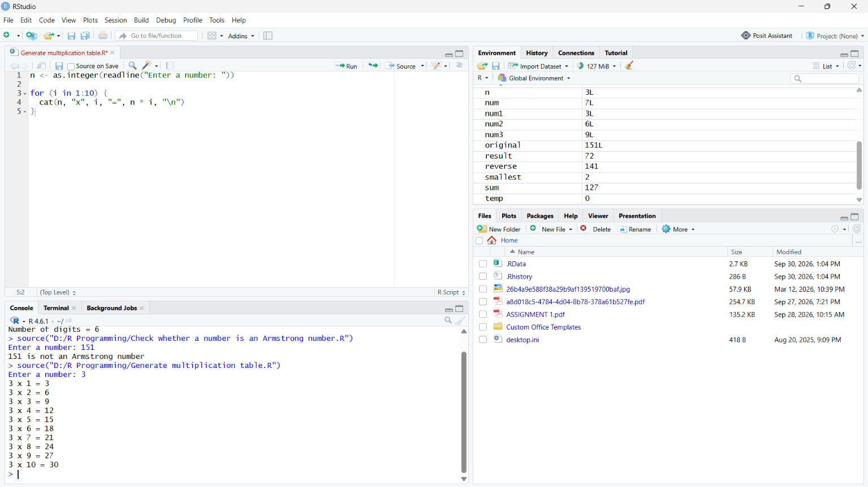
20. Find GCD and LCM of two numbers

a <- as.integer(readline("Enter first number: "))
b <- as.integer(readline("Enter second number: "))

x <- a
y <- b

while (y != 0) {
remainder <- x %% y
x <- y
y <- remainder
}

gcd <- x
lcm <- (a * b) / gcd

cat("GCD =", gcd, "\n")
cat("LCM =", lcm)
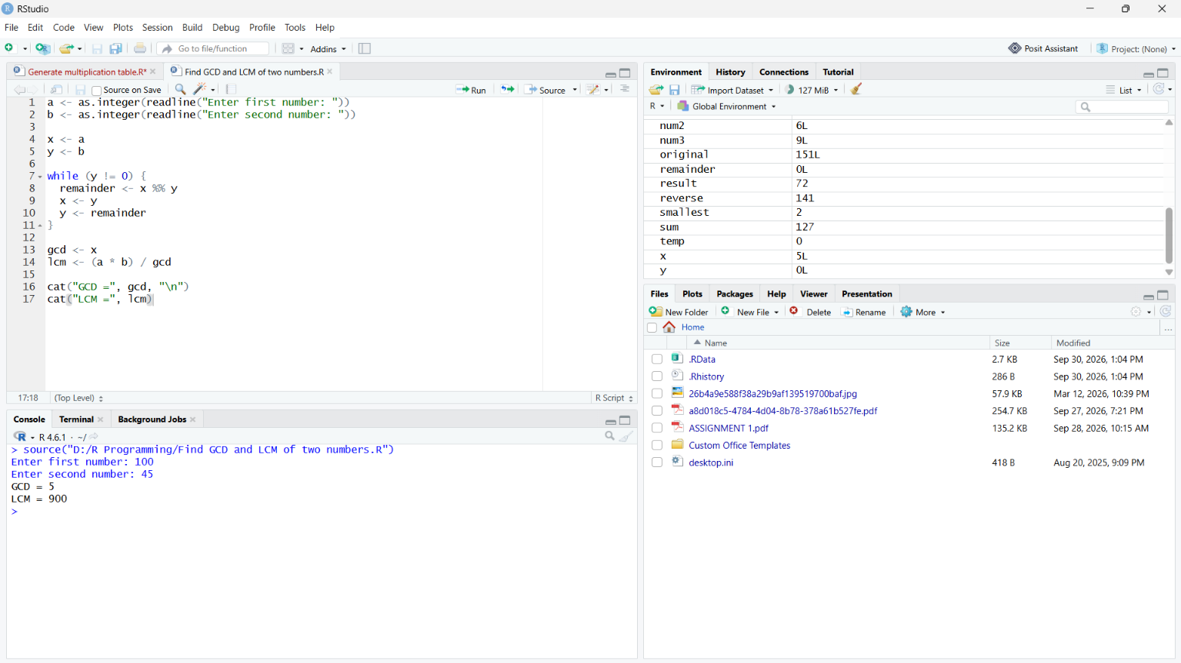
21. Calculate power without using the built-in power operator
base <- as.numeric(readline("Enter base: "))
exponent <- as.integer(readline("Enter exponent: "))

result <- 1

for (i in 1:exponent) {
result <- result * base
}

cat(base, "raised to", exponent, "=", result)

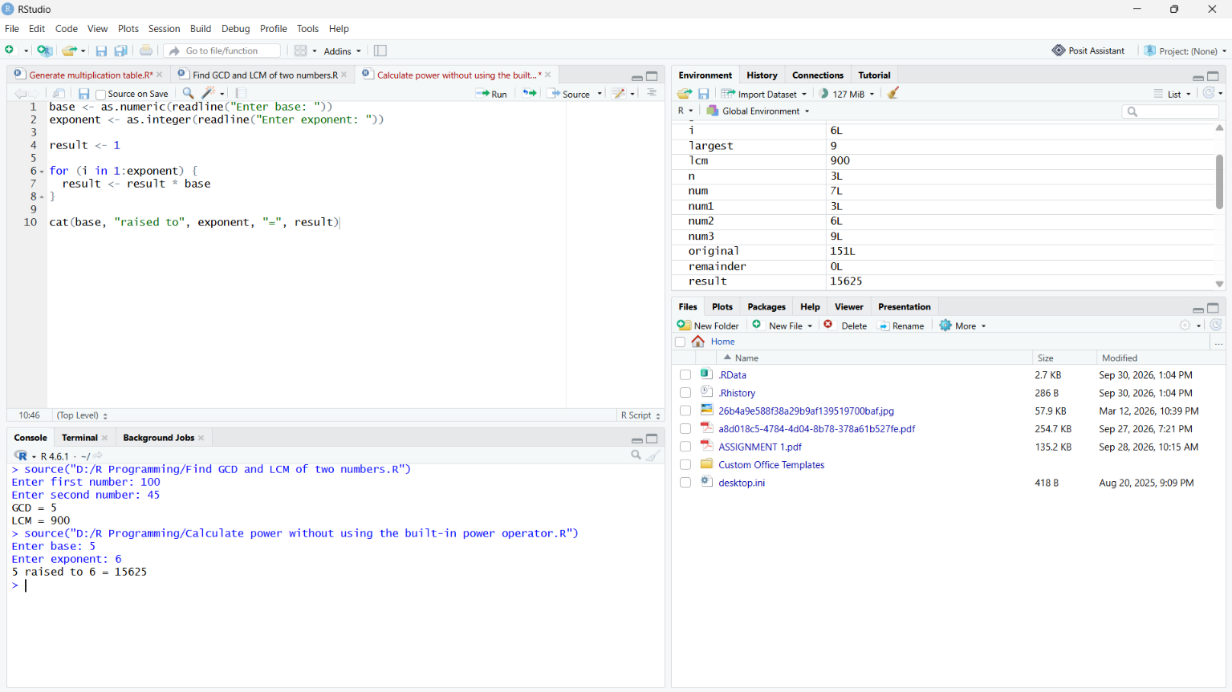

22. Print all even and odd numbers between 1 and n

n <- as.integer(readline("Enter n: "))

cat("Even numbers: ")

for (i in 1:n) {
if (i %% 2 == 0) {
cat(i, " ")
}
}

cat("\nOdd numbers: ")

for (i in 1:n) {
if (i %% 2 != 0) {
cat(i, " ")
}
}
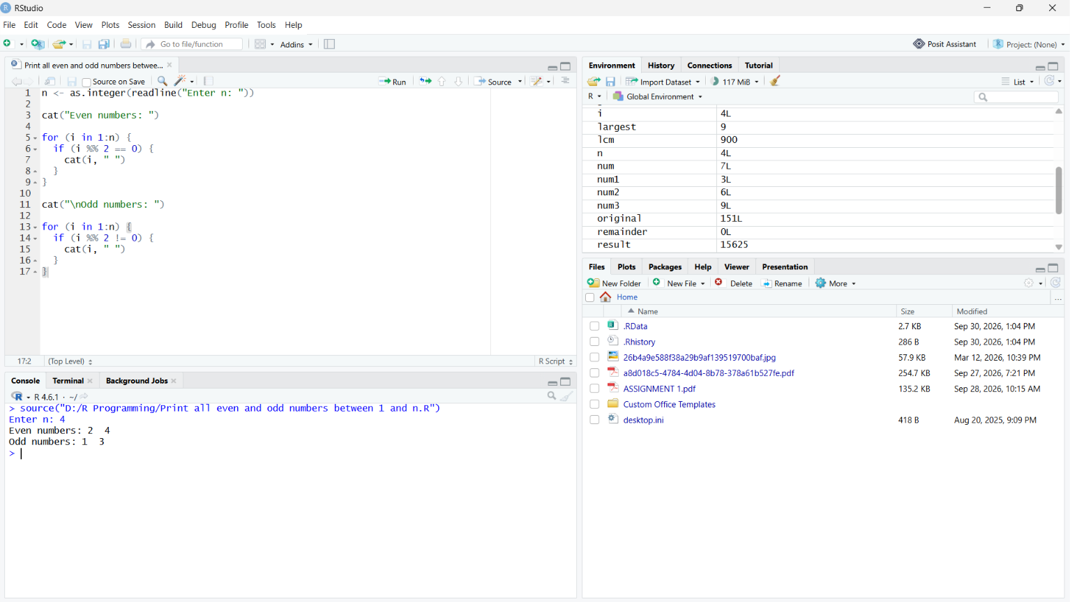

23. Find sum and average of elements in a vector

v <- c(10, 20, 30, 40, 50)

sum <- 0

for (i in 1:length(v)) {
sum <- sum + v[i]
}

average <- sum / length(v)

cat("Sum =", sum, "\n")
cat("Average =", average)

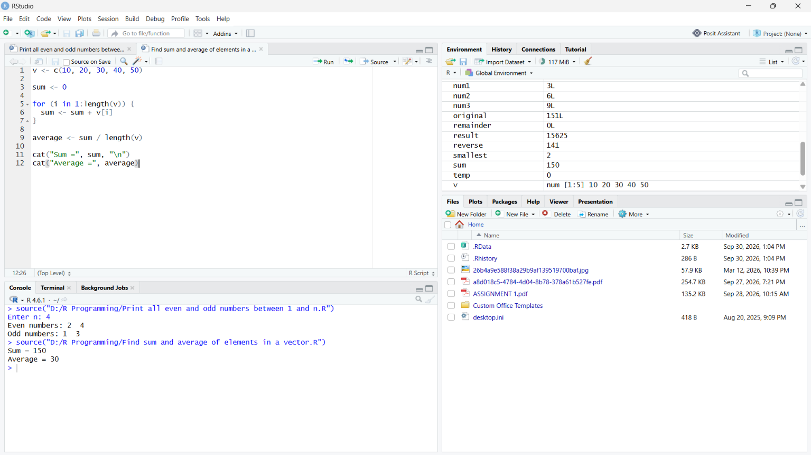

24. Find maximum and minimum in a vector without max() and min()
v <- c(25, 10, 45, 5, 30)

largest <- v[1]
smallest <- v[1]

for (i in 2:length(v)) {

if (v[i] > largest) {
largest <- v[i]
}

if (v[i] < smallest) {
smallest <- v[i]
}
}

cat("Maximum =", largest, "\n")
cat("Minimum =", smallest)
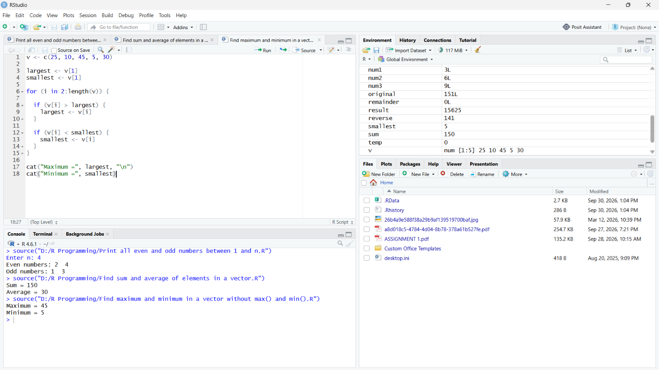

25. Count positive, negative and zero values in a vector
v <- c(10, -5, 0, 20, -10, 0, 15, -2)

positive <- 0
negative <- 0
zero <- 0

for (i in 1:length(v)) {

if (v[i] > 0) {
positive <- positive + 1

} else if (v[i] < 0) {
negative <- negative + 1

} else {
zero <- zero + 1
}
}

cat("Positive values =", positive, "\n")
cat("Negative values =", negative, "\n")
cat("Zero values =", zero)

